Transformer Winding Specification 2

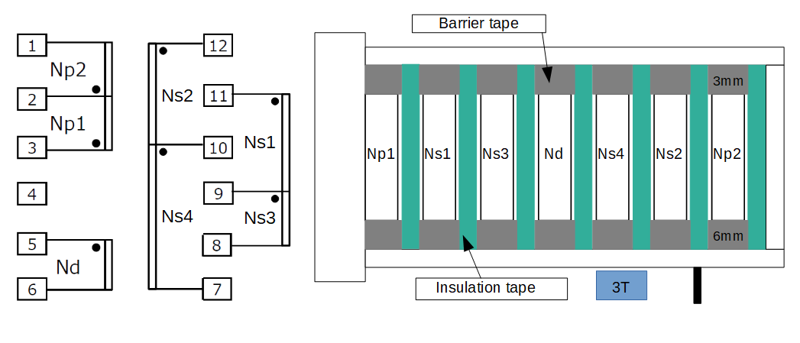

Core: PQ26/20
Bobbin: Vertical/Terminal Pins 6-6(12pins) or compatible
AL – Value: 182.61 nH/N²
Inductance (1 – 3 pin): 250 µH (0.250 mH ±10%)
Copper wire current density: 6 A/mm²
Primary to secondary isolation: ≥ 4kV

Coil | Pin number | Number of turns | Wire gauge
Np1 | ‘3-2 | 18 | SWG #26
Ns1 | ‘11-9 | 23 | SWG #25
Ns3 | ‘9-8 | 5 | SWG #25
Nd | ‘5-6 | 8 | SWG #29
Ns4 | ‘10-7 | 5 | SWG #25
Ns2 | ‘12-10 | 23 | SWG #25
Np2 | ‘1-2 | 19 | SWG #26

Winding direction: Uniformed

